FACTORIAL OF TWO NUMBERS:

AIM: TO PERFORM FACTORIAL OF TWO NUMBERS USING 8085 PROCEESOR.

PROGRAM:

LXI H, 8000H

MOV B,M

MVI D, 01H

FACT: CALL MUL

DCR B

JNZ FACT

INX H

MOV M,D

HLT

MUL: MOV E,B

XRA A

ML: ADD D

DCR E

JNZ ML

MOV D,A

RET

HLT

INPUT:

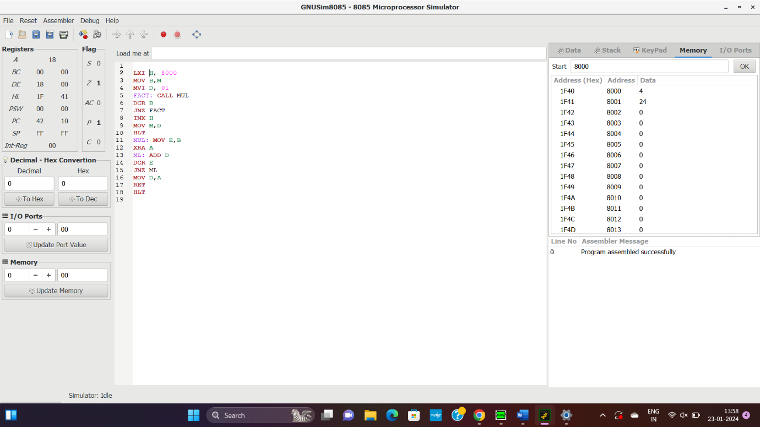

OUTPUT:

RESULT: THUS THE PROGRAM WAS EXECUTED SUCESSFULLY USING 8085 PROCESSOR.